 |  | April 27, 2026

Ivy Tech College School of Information Technology ChatBot User Documentation
 | Prepared for: | Prepared by:
 | Ivy Tech College  School of Information Technology  SDEV 265 - Spring 2026  Steve Carver, Ed. D., MS, MS | Green Team:  Gislaine Azevedo  Zachary Thomas  Kirnechla Davis  Kipp Shinabarger

Contents
Contents 2
Introduction 3
Accessing the Chatbot 3
Starting the Chatbot Session 4
Using the Chatbot 4
Asking Questions 5
Understanding Responses 5
Error Handling / Unrecognized Questions 6
Details 6
User Interaction 6
Understanding User Questions 7
Providing Responses 7
Handling Unknown Questions 7
System Improvement 7
Summary 8

Introduction
This document provides instructions for using the Ivy Tech Chatbot application. The chatbot is designed to assist students, faculty, and visitors by providing quick and accurate answers to common questions related to the School of Information Technology. Users can interact with the chatbot through a simple interface by typing questions and receiving automated responses in real time.
The chatbot helps users find information such as campus details, research assistance, course-related questions, and general academic support. This document explains how to access the chatbot, how to use its features, and how to interact with it effectively to get the best results. It also serves as a guide for understanding how the system responds to user input and how it continues to improve over time.

Accessing the Chatbot
Follow the steps below to access the chatbot application:
- Open the chatbot web application in your browser.
- Navigate to the chatbot page (example: IvyBot interface).
- Wait for the chatbot interface to load.
- Select your preferred language to begin.

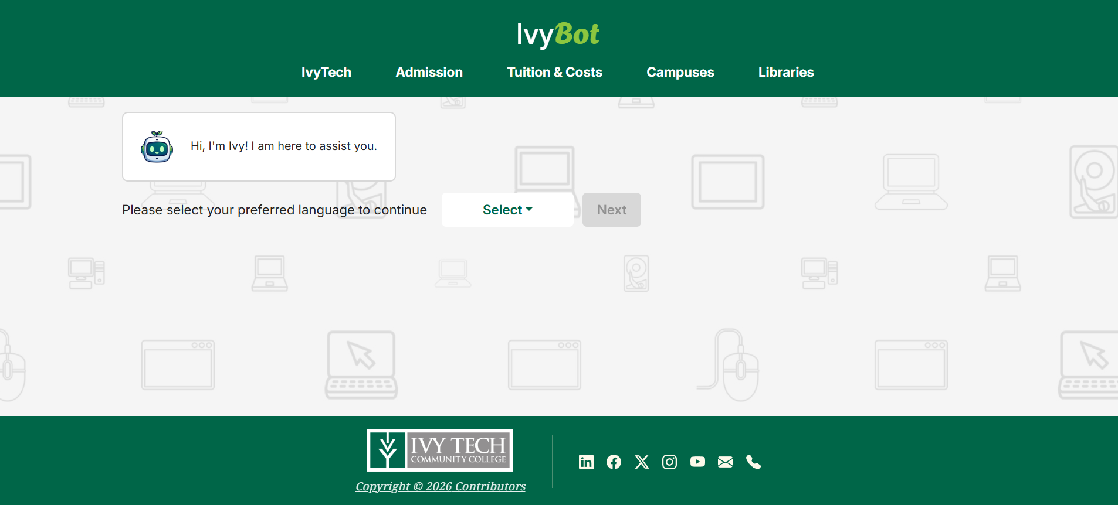
Figure 1
As shown in Figure 1, the chatbot welcomes the user and prompts them to select a preferred language before beginning interaction.

Starting the Chatbot Session
After selecting a preferred language, the chatbot will guide the user through a short setup process before interaction begins
Users will be asked to:
- Select their role (Guest, Student, Faculty, or Staff)
- Enter their Ivy Tech school email address
- Proceed to the main chatbot interface
Once this information is provided, the chatbot opens the main interaction screen where users can begin typing questions.
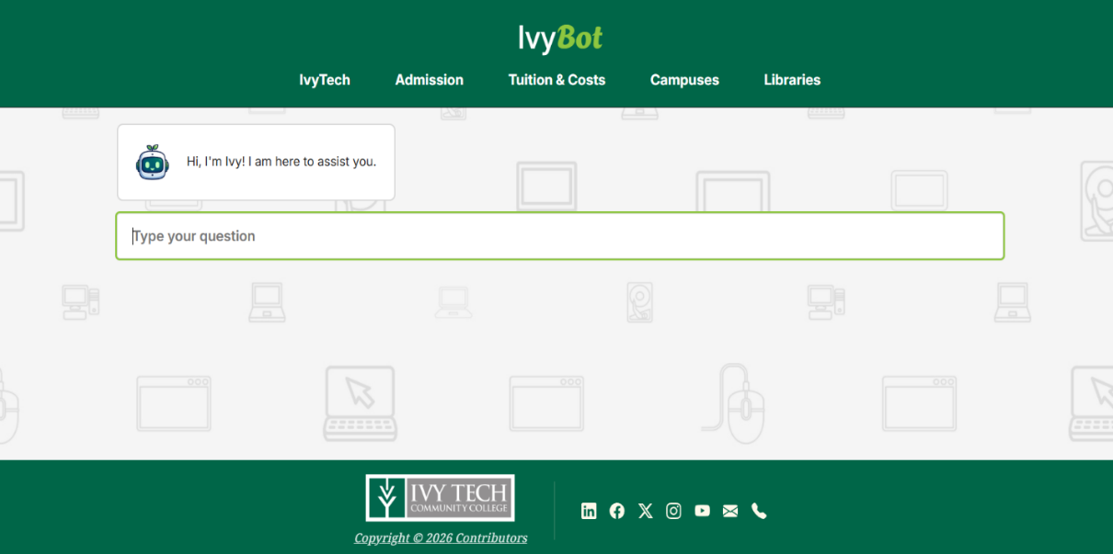
Figure 2
As shown in Figure 2, the chatbot displays a text input field where users can type their questions and begin interacting with the system.

Using the Chatbot
The chatbot is designed to be simple and intuitive. Once the setup process is complete, users can begin interacting with the system using natural language.
To use the chatbot:
- Click on the message input field
- Type your question or request
- Press Enter to submit the message
- Wait for the chatbot to generate a response
The chatbot processes user input by analyzing keywords and matching them to predefined intents. Once the correct intent is identified, the system retrieves a relevant response and displays it instantly.

Asking Questions
The chatbot works best when users ask clear and simple questions. It recognizes different variations of similar questions using predefined patterns.
Examples of questions you can ask:
- “Help with research”
- “Where can I find sources?”
- “Campus contact information”
- “How do I find academic articles?”
Tips for better results:
- Use simple and direct language
- Avoid very long or complex sentences
- Try rephrasing your question if needed
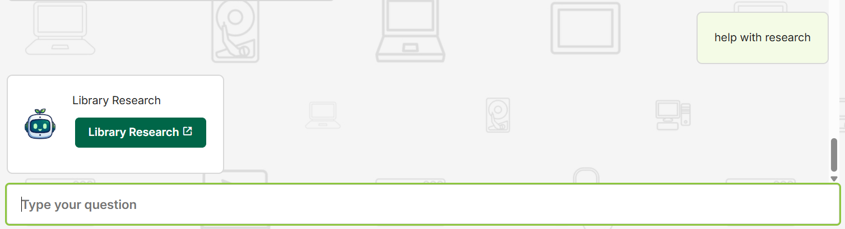
Figure 3

Understanding Responses
Once a question is submitted, the chatbot will analyze the input and match it to an intent. Each intent is connected to a response stored in the system.
Responses may include:
- Direct answers
- Instructions
- Helpful links (such as course catalog or resources)
If multiple responses are available, the chatbot may choose one that best fits the question.

Error Handling / Unrecognized Questions
If the chatbot does not understand a question, it will return a helpful message instead of failing completely. The system is designed to guide users by suggesting alternative questions that it can recognize.
For example, if a user enters a question that does not match any predefined intent, the chatbot will display a message such as:
- “Sorry, I didn’t understand your question.”
- Suggested example questions the user can try
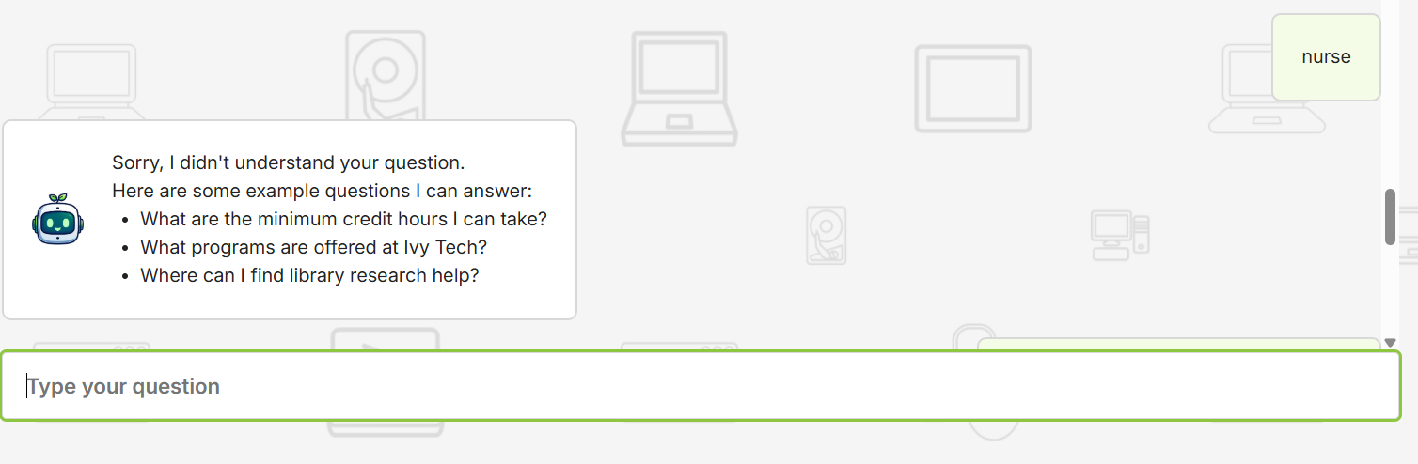
Figure 4

Details
This section explains how the main features of the chatbot were implemented based on the system requirements identified during development.

User Interaction
The chatbot was designed to allow users to communicate easily through a text-based interface. This was implemented by creating a simple input field where users can type questions in natural language. The goal was to make the system accessible to all users, even those without technical experience. This feature allows users to quickly ask questions and receive immediate responses.

Understanding User Questions
The chatbot was developed to recognize different types of user questions. This was implemented using pattern matching, where the system compares user input with predefined phrases. Even if users phrase questions differently, the chatbot can still understand the intent. This improves accuracy and makes the interaction feel more natural.

Providing Responses
Once a question is recognized, the chatbot provides a response linked to that type of request. This was implemented by connecting each intent to a set of predefined answers. This allows the chatbot to respond quickly and consistently, helping users find the information they need without delays.

Handling Unknown Questions
The chatbot was also designed to handle situations where it cannot understand a user’s input. Instead of failing, the system provides a helpful message along with suggested questions. This was implemented through a fallback response system that guides users toward supported topics and improves overall usability.

System Improvement
The chatbot includes a feature that allows it to improve over time. User interactions, especially unrecognized questions, are stored and reviewed. This helps developers identify missing responses and expand the chatbot’s knowledge. This ensures the system continues to grow and become more accurate.

Summary
The Ivy Tech Chatbot is a user-friendly application designed to provide quick and helpful responses to common questions. By using features such as intent recognition, automated responses, and conversation logging, the chatbot delivers an efficient and accessible user experience.
This documentation provided step-by-step instructions on how to access and use the chatbot, supported by real examples and screenshots. It also explained how system requirements were implemented to ensure functionality and usability. While the chatbot already offers valuable support, it can continue to improve through updates and user feedback. Overall, the system serves as a useful tool for students and enhances access to important academic information.

